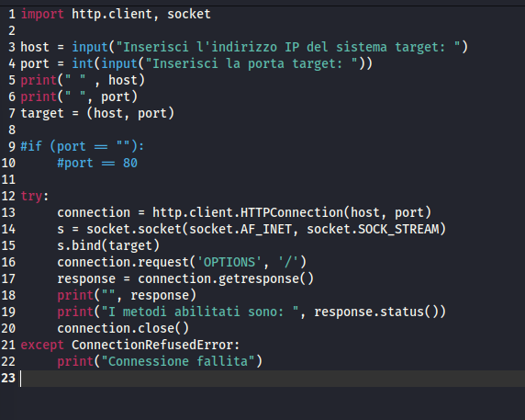

import http.client, socket

host = input("Inserisci l'indirizzo IP del sistema target: ")

port = int(input("Inserisci la porta target: "))

print(" " , host)

print(" ", port)

target = (host, port)

#if (port == ""):

#port == 80

try:

connection = http.client.HTTPConnection(host, port)

s = socket.socket(socket.AF_INET, socket.SOCK_STREAM)

s.bind(target)

connection.request('OPTIONS', '/')

response = connection.getresponse()

print("", response)

print("I metodi abilitati sono: ", response.status())

connection.close()

except ConnectionRefusedError:

print("Connessione fallita")